**14th Prestigious Research Lecture: “ART: Do or die”**

On Tuesday, 29th November 2016, the Health Sciences Research Office hosted the 14th Prestigious Research Lecture.  The lecture entitled “ART: Do or die” was presented by **Professor Ian Sanne** (Director of the Clinical HIV Research Unit and the Chief Executive Office of Right to Care) and **Professor Francois** **Venter** (Deputy Director of the Wits Reproductive Health and HIV Institute). **Ms Qedani Mahlangu** (Gauteng MEC for Health) and **Mr Anele Yawa** (General Secretary of the Treatment Action Campaign) acted as commentators.

The Lecture was focused on the development of HIV treatment and was based on research conducted in the Faculty of Health Sciences, University of the Witwatersrand. A comprehensive overview was given in the lecture which covered the history of access to antiretroviral treatment (ART).This ranged from the pre-ART era, through the introduction of generic drugs, to efforts to use modern technology in order to simplify access to treatment. The presenters were optimistic that the fight against HIV infections will be won. Professor Sanne pointed out that “While a cure for HIV/AIDS is not yet in sight, we know that treatment works”. For the past 20 years we have been working on improving drugs, optimising adherence and making treatment accessible to all people living with HIV, including the six million people living with HIV in South Africa”. The same optimism was echoed by Professor Venter who explained that “New drugs such as *dolutegravir* and *tenofovir alafenamide* promise to make first line regimens safer and cheaper, if successful in clinical trials”.

Professor Sanne further highlighted ART as prevention long-acting injectable ART, Pharmacy Automation and the potential for an HIV cure in the long term. The pharmacy automation system “Patient Dispensing Units” will allow patients to access their medication with their personal IDs which the system will read and link with their records. In this way the medication will be dispensed in the same way as people withdraw cash.

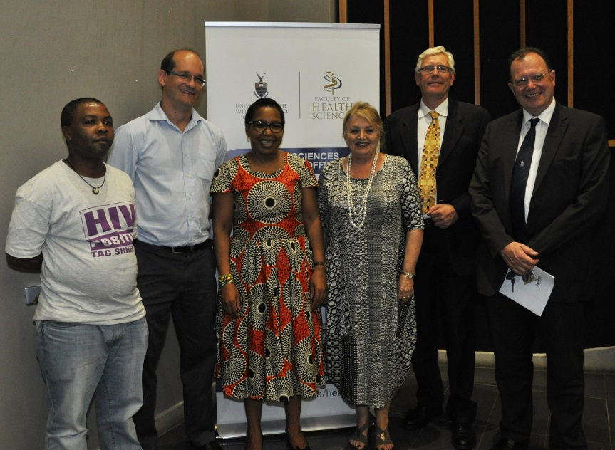

Photograph (left to right): Mr Anele Yawa, Professor Francois Venter, Ms Qedani Mahlangu, Professors Beverley Kramer, Ian Sanne and Martin Veller